**LAB Assignment-02**

*Course title: Computer Graphics Laboratory*

*Course code: CSE-304*

*3nd  Year 1st Semester Examination 2022*

**Date of Submission**: 04-0-2023



**Submitted to-**

*Dr. Mohammad Shorif Uddin*

*Professor*

*Dr. Morium Akter*

*Associate Professor*

*Department of Computer Science and Engineering*

*Jahangirnagar University*

*Savar, Dhaka-1342*

|  |  |  |  |
| --- | --- | --- | --- |
| **Sl** | Class Roll | Exam Roll | Name |
| 01 | **385** |  | **Md.Soad Anam** |

**Experiment No. : 01**

**Experiment Title : Scan conversion of a circle using midpoint**

**Source Code:**

#include<graphics.h>

#include<conio.h>

#include<stdio.h>

#include<bits/stdc++.h>

using namespace std;

int main()

{

int x,y,x_mid,y_mid,radius,dp;

int g_mode,g_driver=DETECT;

//clrscr();

initgraph(&g_driver,&g_mode,"C:\\TURBOC3\\BGI");

printf("*********** MID POINT Circle drawing algorithm ********\n\n");

printf("\nenter the coordinates= ");

scanf("%d %d",&x_mid,&y_mid);

printf("\n now enter the radius =");

scanf("%d",&radius);

x=0;

y=radius;

dp=1-radius;

do

{

putpixel(x_mid+x,y_mid+y,RED);

putpixel(x_mid+y,y_mid+x,RED);

putpixel(x_mid-y,y_mid+x,RED);

putpixel(x_mid-x,y_mid+y,RED);

putpixel(x_mid-x,y_mid-y,RED);

putpixel(x_mid-y,y_mid-x,RED);

putpixel(x_mid+y,y_mid-x,RED);

putpixel(x_mid+x,y_mid-y,RED);

if(dp<0) {

dp+=(2*x)+1;

}

else{

y=y-1;

dp+=(2*x)-(2*y)+1;

}

x=x+1;

}while(y>x);

getch();

}

**Output:**

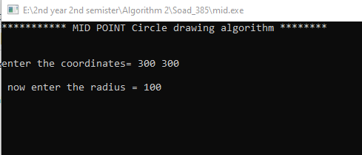

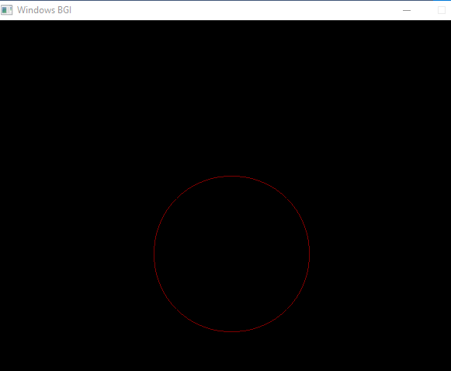

**Fig: Scan conversion of a circle using midpoint**

**Experiment No. : 02**

**Experiment Title : Scan conversion of a Elipse.**

**Source Code:**

#include<stdio.h>

#include<conio.h>

#include<graphics.h>

#include<math.h>

#include<bits/stdc++.h>

using namespace std;

void disp();

float x,y;

int xc,yc;

int main()

{

int gd=DETECT,gm,a,b;

float p1,p2;

//clrscr();

initgraph(&gd,&gm,"c:\\turboc3\\bgi");

printf("*** Ellipse Generating Algorithm ***\n");

printf("Enter the value of Xc\t");

scanf("%d",&xc);

printf("Enter the value of yc\t");

scanf("%d",&yc);

printf("Enter X axis length\t");

scanf("%d",&a);

printf("Enter Y axis length\t");

scanf("%d",&b);

x=0;y=b;

disp();

p1=(b*b)-(a*a*b)+(a*a)/4;

while((2.0*b*b*x)<=(2.0*a*a*y))

{

x++;

if(p1<=0)

p1=p1+(2.0*b*b*x)+(b*b);

else

{

y--;

p1=p1+(2.0*b*b*x)+(b*b)-(2.0*a*a*y);

}

disp();

x=-x;

disp();

x=-x;

delay(50);

}

x=a;

y=0;

disp();

p2=(a*a)+2.0*(b*b*a)+(b*b)/4;

while((2.0*b*b*x)>(2.0*a*a*y))

{

y++;

if(p2>0)

p2=p2+(a*a)-(2.0*a*a*y);

else

{

x--;

p2=p2+(2.0*b*b*x)-(2.0*a*a*y)+(a*a);

}

disp();

y=-y;

disp();

y=-y;

delay(50);

}

getch();

closegraph();

}

void disp()

{

putpixel(xc+x,yc+y,7);

putpixel(xc-x,yc+y,7);

putpixel(xc+x,yc-y,7);

putpixel(xc+x,yc-y,7);

}

**Output:**

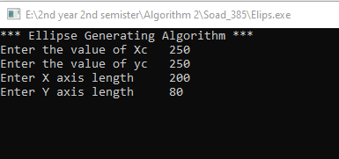

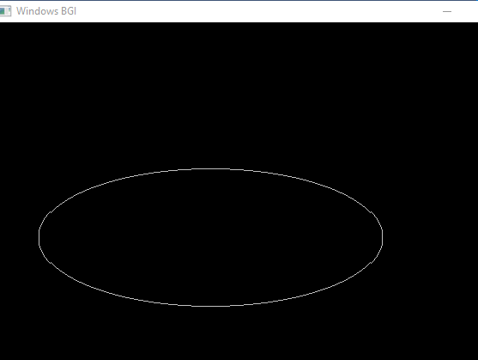

**Fig: Scan conversion of a Elipse.**